Ethel Waddell Githii Honors Program
Student Guide
(Updated August 2023)

The E.W. Githii Honors Program Rationale and Mission

Honors Programs can be found across the nation, in high schools and in colleges and universities. These programs share certain features—the first being the expectation of high academic commitment and integrity among the faculty and student membership. We share that expectation. However, Programs are often distinctive according to the ways that they affirm their unique populations, geographies and missions.

The Ethel Waddell Githii Honors Program exists to encourage an intimate, supportive and engaged intellectual environment—spaces that foster a strong sense of connection and community among women of African descent. Women arrive at Spelman College from diverse geographies, economic circumstances and situations. They bring with them different memories and different dreams. The Program believes that it can express the urgency of building and preserving, among diverse Black women, the kinds of environments that have, do and must exist for us. Our students are in a unique position to produce here and beyond the gates of the College, the environments that we require. Honors expects our students to prioritize their intellectual relationships and balance their academic work with their social engagements.

What makes Githii Honors distinctive? Our program structures and personnel should, whenever possible, reveal ways that students’ scholarly / creative research and writing situates them as “insiders,” owners of a powerful African American liberatory tradition of visionaries, scholars, artists, inventors, healers, scientists, public intellectuals and political actors.

The Githii Honors Program strives to encourage interdisciplinary engagement and questioning in order to embrace an important legacy, and reveal the relevance of all of our areas of scholarly investigation and production.

Admissions Criterion

Entering First Year students:
Students applying from high school may be invited apply to the Honors Program if they have a demonstrated record of high achievement and whose habits as intellectually curious, committed students are evident in their record of engagement beyond the classroom through their leadership, service, and other commitments. The Honors Program Committee considers this in addition to a formal essay composed in response to a guided prompt. These criteria are routinely evaluated and subject to change.

Academic Year 2023-24. Students with a strong academic record and demonstrated commitment to her own intellectual development will be invited to apply for the Honors Program. Any student that has achieved a high school GPA of at least a 4.0 will receive an invitation. Prospective Honors Program applicants must apply in the Early Decision or Early Action application rounds. Those who are invited will be required to submit an additional essay, provided in the invitation. The committee looks at the ways that applicants represent a commitment to serious intellectual engagement and a broad consideration of ideas in organizing their responses. We also expect well organized, carefully edited, controlled and thoughtful prose that demonstrates one’s readiness to thrive in a single semester of honors composition at the collegiate level.

In “Good Standing” and Letters of Appeal

Members who wish to graduate with Full Program Honors must be consistently enrolled at the College for at least 12 hours per semester; meet the Program expectations for intellectual engagement and course completion; maintain a 3.2 annual grade point average, and avoid earning a grade of “F” in any course.

Students will be notified by the Honors Director if their GPA falls below our requirements. However, a student who is having difficulty in her courses, or who is just not doing as well as she feels she could, should not be silent about her difficulties. We are a community. Consult with your faculty and then with the Honors Director early in your effort to strengthen your work.

In addition to GPA, being in good standing requires habits of engagement in person or through communications with students, faculty, and staff at Spelman College on Zoom, through email, or other social media platforms. All communications should indicate maturity, respect and concern for human dignity, and routine courteousness. Archival traces of Honors student participation in these ways must consistently show evidence of a serious commitment to ethical principles of engagement in order to maintain “good standing.”

Students in the Honors Program must also demonstrate intellectual sovereignty as a habit of mind throughout her matriculation. Failing to make progress in this regard can also jeopardize membership in the Program.

Students who are dismissed from Honors for GPA, habits of engagement infractions through a failure to document intellectual sovereignty or through unbecoming behavior, must meet with the Director and, if it is feasible, request Honors Probation by submitting a formal appeal, in writing. The letter of appeal offers an opportunity to provide the details of your case and why the dismissal should be put on hold.

Honors Program Curriculum

The Honors Program curriculum functions within a loose framework of courses intended to bring breadth and interdisciplinarity to our students’ perspectives as critical thinkers, questioners and future professionals. Course offerings will change from semester to semester, but always with an eye to making important connections to your location within the global picture, and your professional or graduate school plans.

All Honors Program courses and seminars fulfill College core curriculum or graduation requirements.

Required Courses:

CORE
ENG 193: Honors First Year Writing
PHIL 191: Honors Philosophy

INTERDISCIPLINARY ELECTIVES: All students who wish to graduate with Honors will select two 300-400 level elective courses in addition to the CORE courses.

Two Honors elective courses

Honors Thesis Research or Capstone equivalent
All students who wish to graduate with Honors will prepare an Honors thesis or Portfolio equivalent. Many major departments have an internal thesis sequence, which can satisfy the requirements of the Honors Program. Students must attend an Honors thesis workshop to clarify their specific needs to satisfy the requirement.

ENG 193 – HONORS FIRST YEAR COMPOSITION (4)
A spectrum of writing experiences from analysis to argument to criticism. Emphasis on readings and extended research from literature and nonfiction prose.

PHI 191 – HONORS PHILOSOPHY SEMINAR (4)
An introduction to ancient and modern philosophy. Designed to be intensive. Critical study of six of Plato’s Dialogues (representing the ancient) and Descartes’ Meditations on First Philosophy (representing the modern).

HONORS ELECTIVES (8)
A wide range of Honors electives across disciplines challenge and engage students. These electives are seminar based courses specially designed by leading Spelman faculty. They are characterized as rigorous, writing and critical thinking intensive, interdisciplinary in content and/or approaches, as well as international or global in scope. Available courses updated on the webpage.

HONORS ELECTIVE OPTION
The Honors Elective Option, or H-Option, is an elective option that allows students to work with a faculty member of their choice inside of a course at the 300+ levels and for Independent Studies courses that they are taking to make it an honors elective option. Concerning the latter, students in the Natural Sciences who use the Independent Study option for summer courses and verifiable research and internship experiences may more readily recognize the relevance of how the independent study pertains. Students must present the H-Option form and the course syllabus to the Honors Program Director for approval no later than the fourteenth day (14) of the course semester. If approved, students would need to earn at least a “B” in their H-Option experience for it to count towards satisfying Honors elective credit.

SENIOR REQUIREMENT: To receive college-wide honors, students may complete a traditional thesis or the Honors Portfolio Project.

HONORS THESIS RESEARCH--TRADITIONAL
Your research is departmentally supervised and approved. Advising for your senior research takes place throughout your four years of study.

HONORS PORTFOLIO— Seniors are tasked by the college with completing the Core Curriculum Assessment by the conclusion of the Spring term. Ethel Waddell Githii Honors Program students choosing the Portfolio project must complete the Core Curriculum Assessment with an obligation to report on how five artifacts selected for the portfolio showcase the influence of being a member of the Honors Program. One of the artifacts must be an original, beyond the classroom project.

ENRICHMENT/ENGAGMENT ACTIVITIES
The character of notably engaged intellectuals reveals a capacity for introspection and curiosity. Honors requires students to make evident the quality of their inner lives through an engagement with activities that sets in relief this inner world. A signature feature of the Ethel Waddell Githii Honors Program, then, is that it is designed to assist you in making independent choices beyond the classroom that showcase seriousness of intellectual purpose. Every student must make satisfactory progress (see below) in order to remain in the Honors Program. Consider the activities below.
Habits of Mind - attend events that enrich your mind or allow you to engage in a meaningful way outside of your courses:
-1x AUC events
-2x Intercampus events (GSU/G-Tech)
-3x Regional events
-4x National events
-5x International events
Scholarly Events
______Academic talks/lectures (2 pts)
______Disciplinary conferences (4 pts)
______Fellowship Foundation Workshops (2 pts)
______Study Abroad informational sessions(2 pts)
______Library programming (2 pts)
______Documentary film screenings (1 point)

Cultural Events
______Museum exhibits and events (1 pt)
______LiveCultural Performances(1 pt)
______Film Festivals (1 pt)
______Cultural Festivals (1 pt)
______Community Performances(1 pt)
______Library programming (2 pts)
______Live musical performances (1 pt)
______NPU Meetings (2 pt)

Habits of Mind – participate in activities and organizations that enrich your mind or allow you to engage in a meaningful way outside of your courses:

Scholarly Involvement
______Intercampus activities/experiences
______Workshops and Webinars (3 pts)
______Domestic Exchange Programs (5 pts)
______International Exchange Programs(10 pts)
______Social Justice Program/Events (1 pt)
______Participate in Honors Program events (5 pts)
______Participate in Alpha Lambda Delta events (3 pts)
______Enroll/Audit classes at the 500+ level (8 pts)
______Audit classes (8 pts)
______Enter competitions (TBD)
______Compete with Quiz Bowl Team (5 pts)
______Attend Spelman College Speech and Debate Team events (2 pts)

Career Development
______Career Planning Events/Corporate Events (1 pt)
______Participate in the Career Fair (1 pt)
______Enroll in Handshake (2 pts)

Miscellaneous
______Subscriptions to professional journals (3 pts)
______Purchase “student business” cards (1 pt)
______Complete Health Sciences forms (2 pts)
______Register to vote (4 points)
______Obtain a library card (1 point)
______Obtain a passport (1 point)
______Apply for research opportunities (2 pts)
______Apply to the Presidential Reading Circle (2 pts)
______Apply for Prestigious Fellowships/Scholarships(5 pts)
______Create short study travel opportunities (4 pts)
______Work independently with an archivist (3 points)
______Arrange "meetings of the mind" (3 points)
______Plan an alternative homecoming (3 points)
______Participate in alternative Spring Break (5 points)
______Foster relationships with other Honors Programs (1 pts)
______Contribute to Journals for Student Research (3 pts)
______Participate in conferences as presenters (6 pts)
______Joining and Paying HPSA Dues (t-shirt) (5 points)
______Purchase Honors Program Blazers/shirts (5 pts)
______Apply for ALD scholarships (2 points)
______Submit articles to ALD Journals (2 points)
______Read Honors Program email and respond (5 pts)
______E-board participation (5 points)
______Applying for Internships (1 point)

Coloring Coding Legend

Black: Honors Program Specific
Blue: Cultural
Orange: Academic
Purple: Career Planning
Red: Flexible/Freestyle=dependent on student major/interest

Goals
- Enrichment
- Promote agency
- Promote intellectual sharing
- Shape scholarly behaviors

Potential Competencies
- Leadership
- Effective Communication (oral/written)
- Intellectual—Writing publications/Critique works

Intellectual Sharing Activities
- Blogs
- Digital Narrative
- Reflections
- Research Journals

Satisfactory Progress to Remain in Honors
- 30 points for Seniors
- 35 points for Juniors
- 40 points for Sophomores
- 50 points for Freshman
- At least 5 points per year must come from the Career Development category
- At least 5 points per year must come from the Cultural category

Notes

- *Students can petition to add events
- *First-year students are encouraged to participate in activities that are on campus
- *To do: Decide which types of learning artifacts will be assessed (i.e. reflections, etc.)

Domestic Exchange and Study Abroad

As an enrichment program, the EWGHP compliments traditional experiences for domestic exchange and study abroad. EWGHP students are strongly encouraged, in fact, to pursue opportunities for domestic exchange and study abroad for enrichment purposes. Through these experiences, students can expect to extend their opportunities to participate in Habits of Mind activities through co-curricular engagement while away. In addition, once students have satisfied their major requirements through domestic exchange and study abroad, they might also seek approval from the EWGHP Director to satisfy EWGHP Honors Program Electives. Students requesting approval for domestic exchange or study abroad courses to satisfy Honors Elective requirements must obtain the form from the EWGHP Coordinator.

Distinctions

Starting with the graduating class of 2024, honors program students will be able to graduate with levels of distinction: Honors with High Distinction, Honors with Distinction, or Honors. These levels will provide greater clarity regarding any student’s investment in the goals and ambitions of the honors program and thus reflect the quality of a student’s participation. The following chart offers guidance on how the quality of a student’s participation will be evaluated.

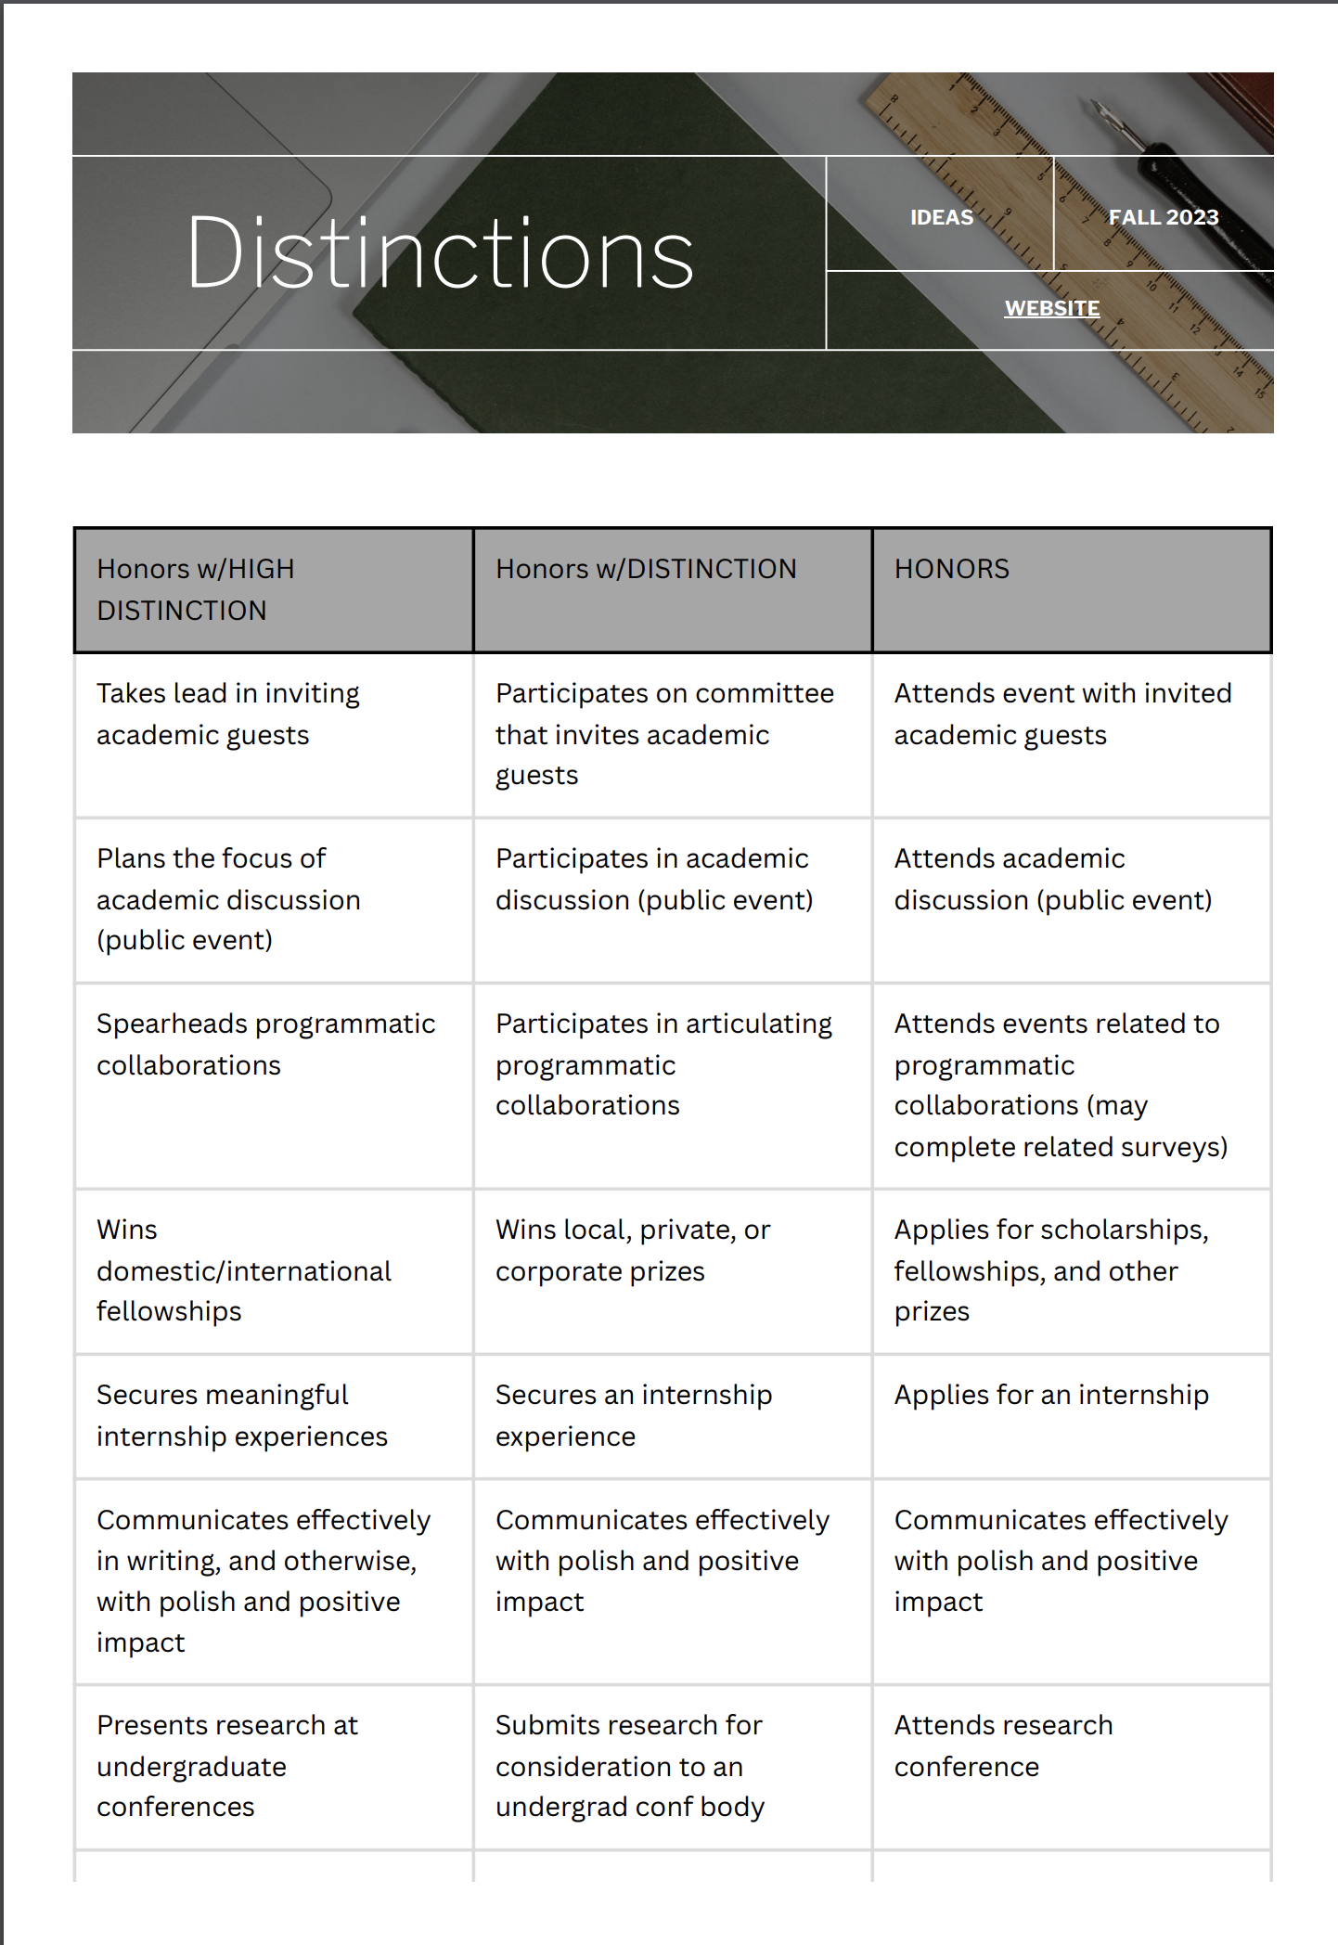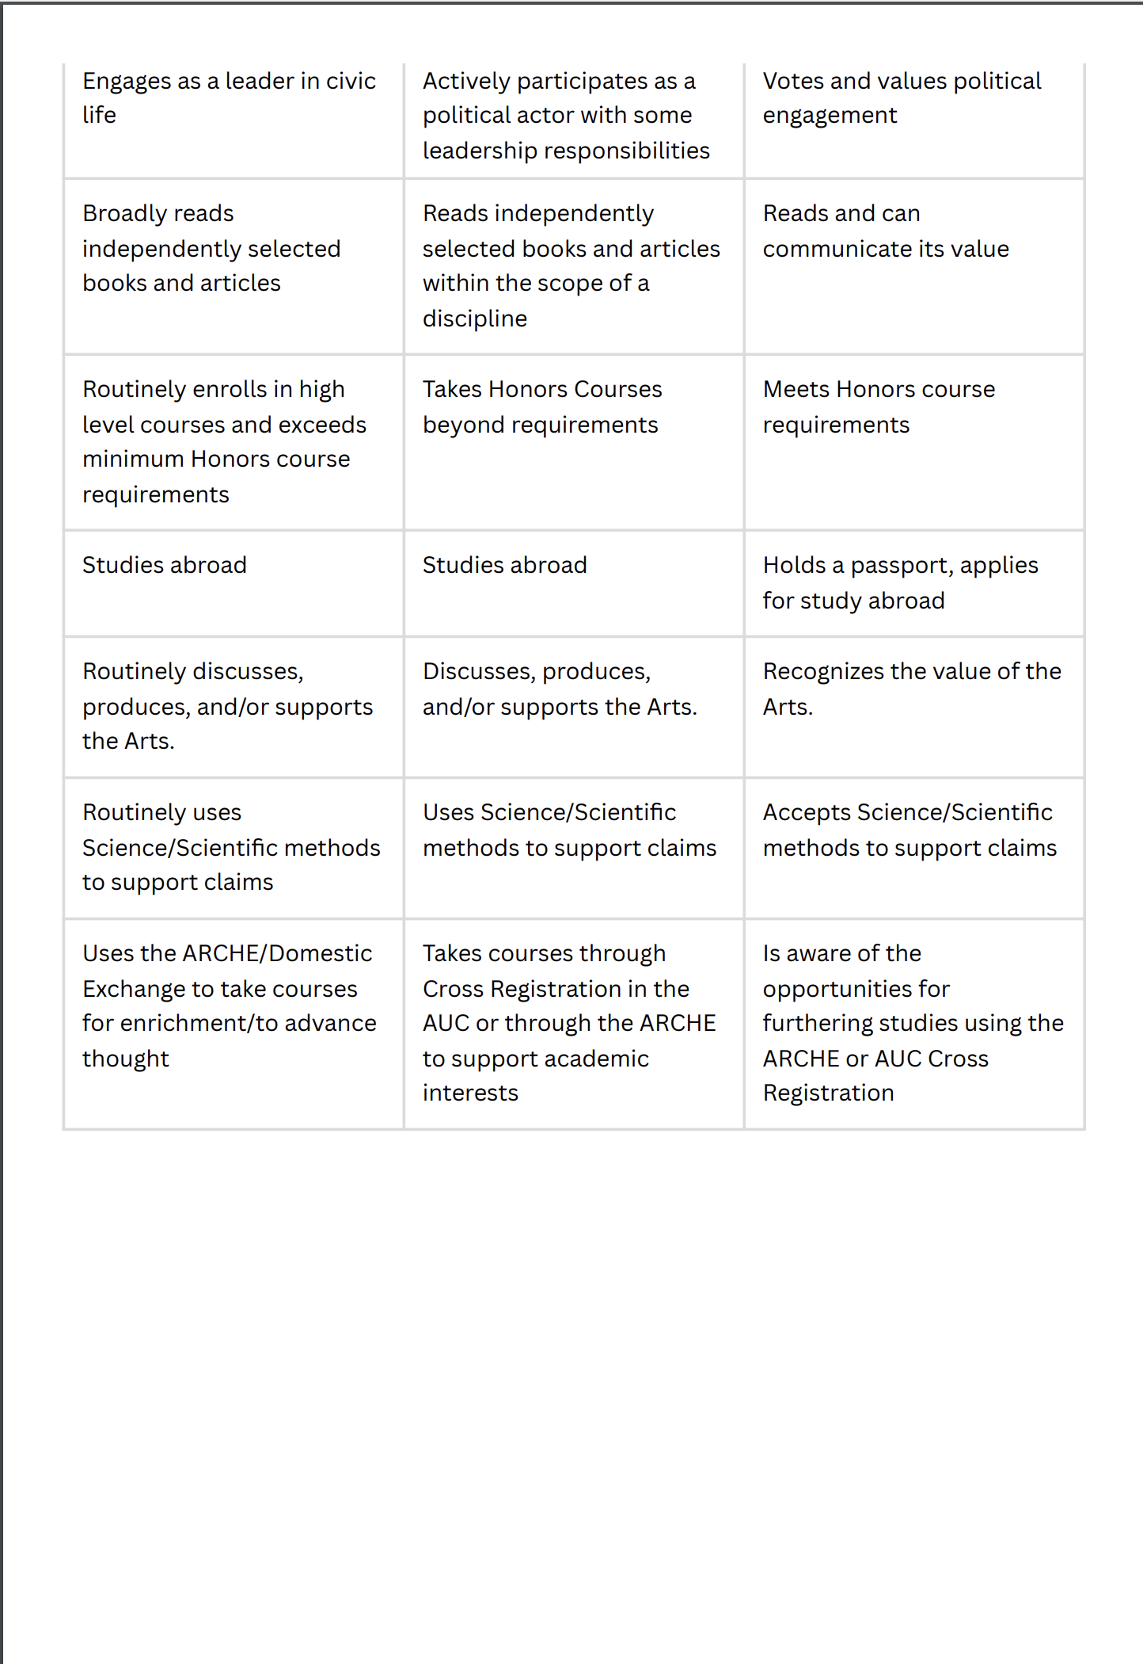

Students will be asked to rate the quality of their participation per semester and the honors program will share this data with department chairs.

The Honors Program Participation Agreement

This Agreement indicates the Honors Program’s interest in developing and supporting the intellectually engaged student. The First Year Honors Retreat as well as the Reading Program and discussions are intended to model the kind of diverse intellectual inquiry and curiosity that defines the women of Githii Honors beyond the expected classroom performance, where you should also model the attitude of intellectual engagement, independent thought, questioning and preparation.

Your first year co-curricular activities are required to maintain your good standing with Honors Program. Beyond the first year, the Honors Program expects to see its students defining and demonstrating “the intellectually engaged, curious, assertive volunteer learner. We expect to see you present at important Honors –sponsored events, developmental workshops, and invite your participation in support or development of programming.

First year activities are required. However, if a student reports that she cannot attend the Honors Retreat, or major book discussions, she must give early notice with documented evidence of her conflicting commitment. The student must then apply with the Director for approval of an alternative engagement either prior to the Retreat, or during the first semester. A student who does not attend the Retreat or the book series and does not demonstrate participation in significant alternatives may be asked to show reasons why she should not be removed from the Honors Program.

Advising: Honors students in “good standing” have priority registration. Therefore, it is wise to meet early with your academic advisor and/or the Honors Director. For major courses, develop a relationship with your department chair early in your academic career, and/or with other faculty in your major department.

Meet with the Honors Director at least once per year, but more frequent visits may be useful in individual cases to review your first year experience and to discuss your participation in co-curricular activities. Meet with your first-year advisor in your second semester, for early registration.

Records kept in the Director’s office are for the purpose of advising and letters of recommendation, and will be shared with Honors faculty only for purposes of recommendation letters, scholarships, internships, graduate programs, etc.

Co-Curricular Activities: Students may meet with the Honors Director, Academic Advisor, or other mentors throughout the year to discuss progress in courses, and broader matters related to preparations for scholarship application, thesis development, career interests and other matters that relate to student development and long-term planning.
INFORMATION RESOURES

Subscribe to your Honors website and to departmental resources to keep abreast of opportunities and information relevant to your development and planning.

Students will take ENG 193 either in the first or second semester, based on available space. Only required by Transfer students if the college has not accepted composition credit.

