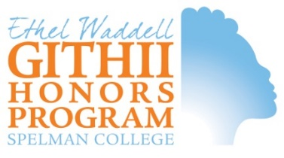
June 5, 2023

Dear Ethel Waddell Githii Honors Program Student,

CONGRATULATIONS again on being admitted to Spelman College and on being selected for membership in the Honors Program! We know that you are excited to join our ranks and we are eager to welcome you.

We begin your long welcome into the intellectual community that we have formed at Spelman during the summer with common texts. As you will soon learn, for us, African American historical expressions of value help define intellectual community in the honors program. Central, then, to our values is the core belief that you belong here. Belonging here means that we accept your expressed commitment to the life of the mind, and we aim to provide you with thorough enrichment so that you will be prepared for engaged membership.

This summer, our community will read these three books:

- You are Your Best Thing: Vulnerability, Shame, Resilience, and the Black Experience, eds. Tarana Burke and Brene Brown
- The Firebrand and the First Lady: Portrait of a Friendship, Patricia Bell-Scott
- All about Love: New Visions, bell hooks

Serious people read; and serious intellectuals do so for the sake of intellectual curiosity and expansion. You should approach these books in that spirit rather than as you might have approached the summer reading you may have done for high school, and so in preparation for a test or a quiz. Our goal is to support your inclusion in discussions and activities that we are preparing for you in the Fall. To that end, you are welcome to read at your own pace as we do not have a reading schedule (with completed page numbers by a particular date) in mind for you. Our honors program retreat will be held in Warm Springs, Georgia and so you might consider reading Patricia Bell-Scott's monograph first.

We look forward to being in community with you soon.

Sincerely,

Michelle S. Hite, Ph.D.
Director

